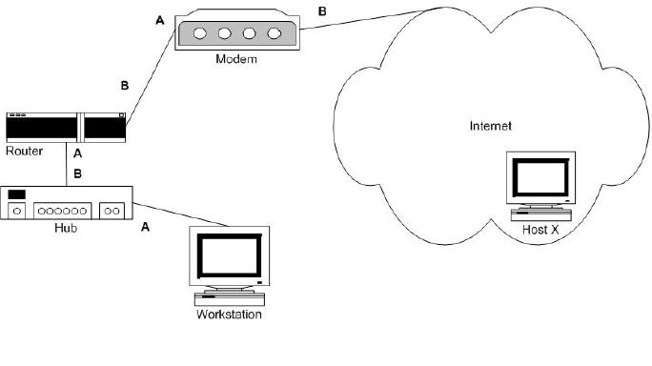
In the configuration shown in the exhibit, the link lights on Interface A
of the router and interface B of the hub are not lit. All other link lights
are lit. Which component could NOT have caused this problem?
A. hub
B. router
C. modem
D. patch cord

In the configuration shown in the exhibit, the link lights on the interface
A of the router and interface B of the hub are not lit. All other link lights are
lit. Which component is LEAST likely to have failed?
A. hub
B. modem
C. router
D. patch card

In the configuration shown the exhibit, the workstation is unable to connect
to Host X. A visual examination reveals the collision light on the hub is
steadily lit. All other
link lights are lit.
Which component is the most likely cause of this problem?
A. A chattering NIC in Host X.
B. A chattering NIC in the workstation.
C. A bad cable between the modem and Host X.
D. A bad cable between the router and the modem.

You have finished building a small home network. You find that you cannot
attach to Host X from your workstation. A visual examination reveals all link lights
are lit. Which component is the most likely cause of this problem?
A. Bad cable
B. Misconfigured router
C. Misconfigured modem
D. More information needed
E. Misconfigured NIC at the workstation
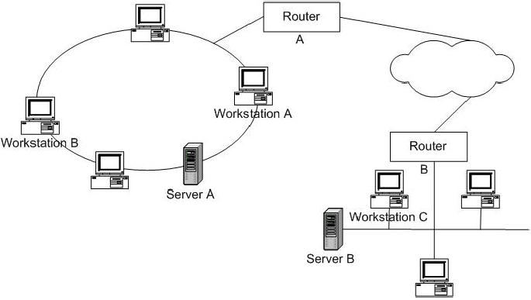
Workstation C cannot access Server A. Workstation C can successfully ping
Server B. Workstation A can access Server A.
Which command should you issue at Workstation C to narrow down where the
network failure is located?
A. Ping router B
B. Tracert Router B
C. Tracert Server A
D. Ping Workstation A

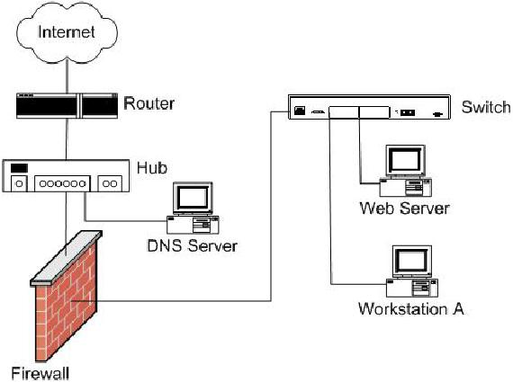

Given:
• External Web users coming in from the Internet are complaining of slow
connectivity to the Web server.
• Workstation A can connect to the firewall without error.
• Workstation A can connect to the Internet without error.
What is the cause of the problem?
A. A jabbering NIC in the Web server
B. A jabbering NIC in the DNS server
C. A bad cable between Workstation A and the switch
D. A bad cable between Web server and the switch

Given:
• External Web users coming in from the Internet are complaining of
intermittent connectivity to the Web Server.
• Workstation A can connect to the Web server without error.
• Workstation A can connect to the firewall without error.
• Workstation A is experiencing intermittent connectivity to the Internet.
What is the cause of the problem?
A. High utilization on the router
B. High utilization on the Web server.
C. A bad cable between Workstation A and the switch.
D. A bad cable between the Web server and the switch.

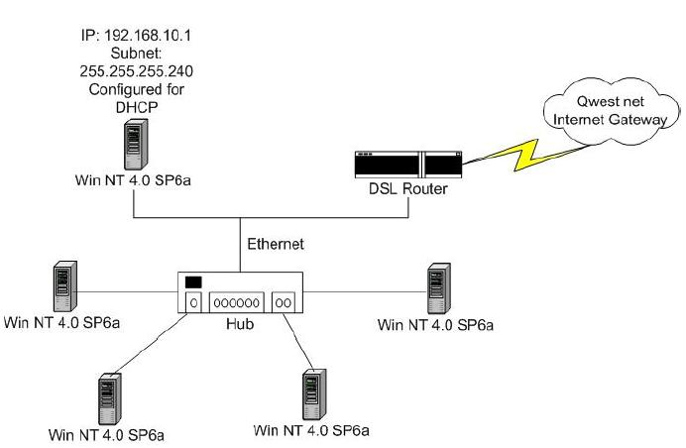
After installing a DSL router in your small office/home office network,
you lose connectivity to your server. You are able to successfully ping the
router. When you issue an ipconfig command you notice your workstation's IP address is
192.145.15.10. What is the cause of this failure?
A. The hub is powered off
B. The Ethernet cable between the hub and the DSL router is bad.
C. The Ethernet cable between the hub and the workstation is bad.
D. The DSL Router is also running DHCP, causing a DHCP conflict.

In the configuration shown in the exhibit, you have just finished building
a small home network. You find that you cannot access the Internet. You ping the DSL
router successfully. You suspect that the default gateway is not set on the
workstation. Which utility should you use to confirm your diagnosis?
A. netstat
B. gateway
C. ipconfig
D. winipcfg

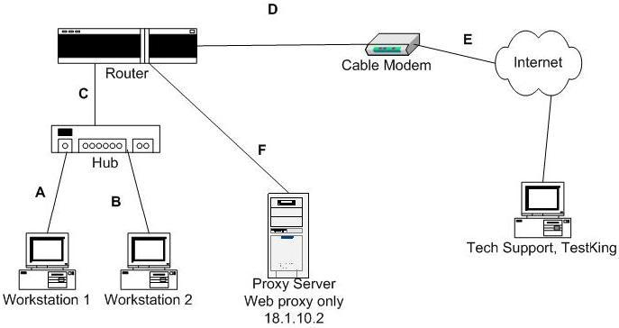
The customer reports loss of Internet connectivity from all workstations. Tech
Support can ping the router but cannot Telnet into it. ICMP port is not open
in the router. Which two steps would be useful in troubleshooting this
problem? (Choose two.)
A. Restart the router.
B. Replace patch cord C.
C. Replace patch cord A.
D. Replace patch cord B
E. Restart the cable modem.

